- Problem: Analog to Digital Signal Conversion

Logical Solution:
- Sampling the time domain with specific period which is attained from sampling frequency.
- It creates discrete time signal.
- Then quantized the sine signal, which makes the signal as discrete valued signal
- Digital signal is both a discrete time signal and discrete valued signal.

Source Code:
#x(t)=cos(2*pi*f*t) plotting from t(-1,1)
import numpy as np
import matplotlib.pyplot as plt

tmin=-1
tmax=1
num_t=1000
t=np.linspace(tmin,tmax,num_t)
#print(t)
f=4
xt=np.cos(2*np.pi*f*t)
plt.plot(t,xt)
plt.xlabel("t")
plt.ylabel("Amplitude")
plt.title("Plot of cosine function")

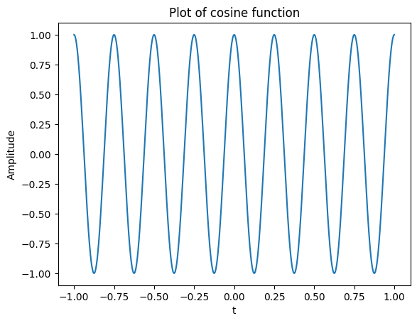
Figure-Sine Signal
#sampling
Fs=30
Ts=1/Fs
pulse_train=np.arange(tmin,tmax, Ts)
#print(pulse_train)
xt_sampled=np.cos(2*np.pi*f*pulse_train)
plt.stem(pulse_train,xt_sampled)
plt.plot(t,xt,'r')

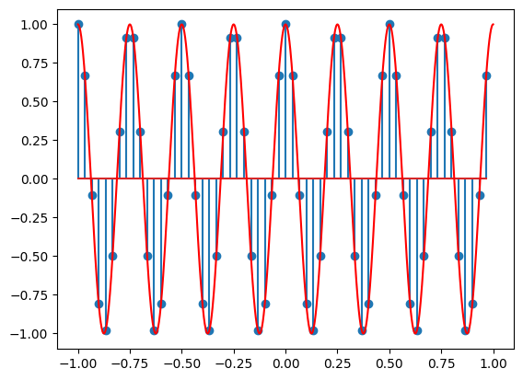
Figure-Sampling Signal

xmin = min(xt_sampled)
xmax = max(xt_sampled)

labels = 11
quantization_step = (xmax - xmin) / (labels - 1)

#include quantization logic here
quantized_signal=[]

for i in xt_sampled:
value=round(i/quantization_step)*quantization_step
quantized_signal.append(value)

quantized_signal=np.array(quantized_signal)

plt.figure()
plt.stem(pulse_train,quantized_signal)
#plt.plot(t, xt, 'r')

for label_value in np.arange(xmin, xmax + quantization_step, quantization_step):
plt.axhline(y=label_value, color='g', linestyle='--')

plt.xlabel("Time")
plt.ylabel("Amplitude")
plt.title("Quantized Signal with Quantization Labels")
plt.show()

Output:

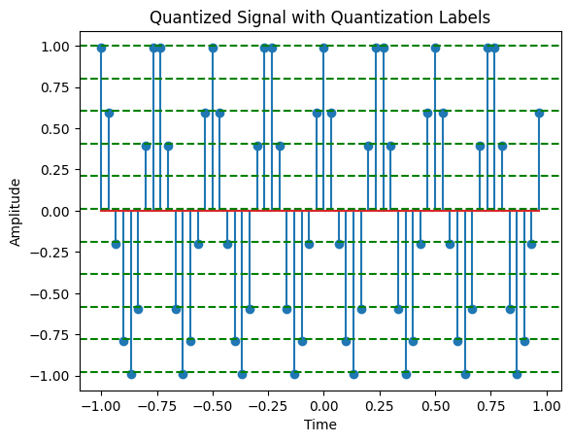
Figure-Quantized Signal
Discussion:
- Using Numpy and Matplotlib module I have implemented the ADC Conversion

- Problem: Display Different kinds of unit signals

Logical Solution:
- Unit sample signal: when n=0 we get value 1.
- Unit sample signal: when n>=0 we get value 1.
- Unit ramp signal: when n>=0 we get value equal to n.

Source Code:
import numpy as np
import matplotlib.pyplot as plt

# Unit sample signal
n=np.array([i for i in range(-5,6,1)])
del_n=[]
for i in n:
if i==0:
del_n.append(1)
else:
del_n.append(0)
del_n=np.array(del_n)
plt.xticks(n)
plt.grid(True)
plt.stem(n,del_n)
plt.show()

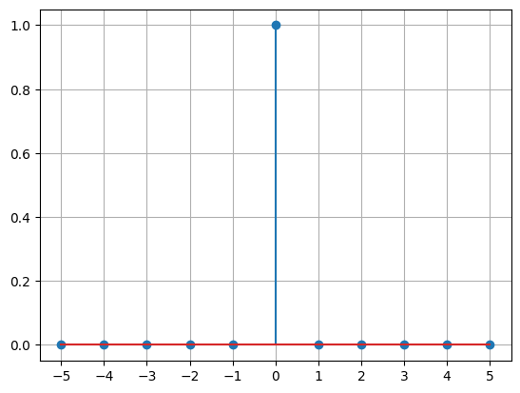
Output-Unit Sample Signal
# unit step signal

u=[]
for i in n:
if i>=0:
u.append(1)
else:
u.append(0)
del_n=np.array(del_n)
plt.grid(True)
plt.stem(n,u)
plt.xticks(n)
plt.show()

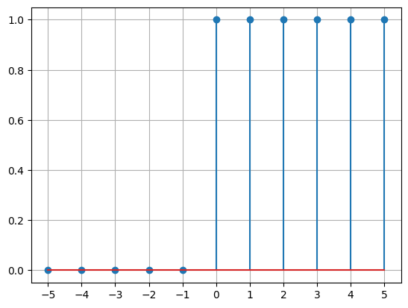
Output- Unit Step Signal

# Unit Ramp signal
ur=[]
for i in n:
if i>=0:
ur.append(i)
else:
ur.append(0)
del_n=np.array(ur)
plt.grid(True)
plt.stem(n,ur)
plt.xticks(n)
plt.show()
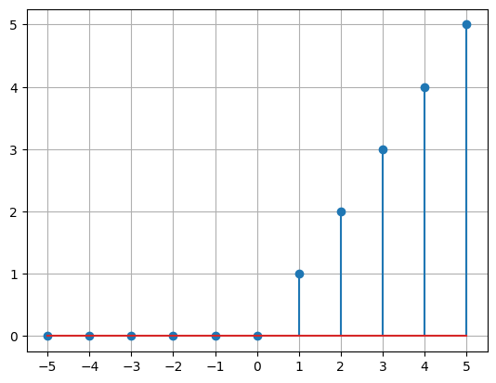
Output- Unit Ramp Signal

Discussion:
- Using matplotlib library I have figured out the signal types.

- Problem: Different kinds of Signal Manipulation Technique
Y(n)=3X(-2n-2)
Logical Solution:
- Shifting- y(n)=x(n-k) k>0: right shifting, k<0 left shifting
- Reversal- y(n)= x(-n)
- Amplitude Scaling- y(n)=Ax(n)
- Time Scaling- y(n)=x(an)

Source Code:
import numpy as np
import matplotlib.pyplot as plt

n=np.array([i for i in range(-8,10,1)])
signal=[]
def value(s):
if s>=0 and s<=6 and round(s)==s:
return 1
return 0

signal=np.array(list(map(value,n)))

# Original Signal
plt.stem(n,signal)
plt.xticks(n)
plt.grid(True)
plt.show()

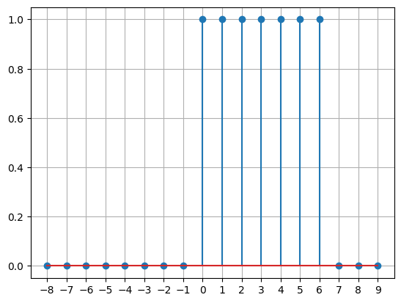
Output- Original Signal
# Shifting:
k=2
modulated=n+k
plt.stem(modulated,signal)
plt.xticks(modulated)
plt.grid(True)
plt.show()

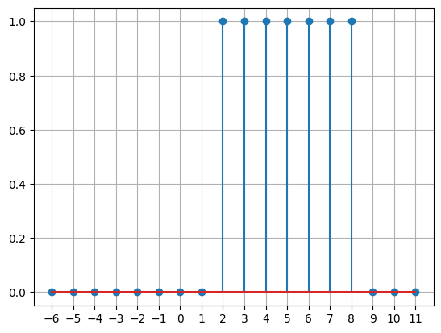
Output- After Shifting

# Reversal
modulated=-modulated
plt.stem(modulated,signal)
plt.xticks(modulated)
plt.grid(True)
plt.show()

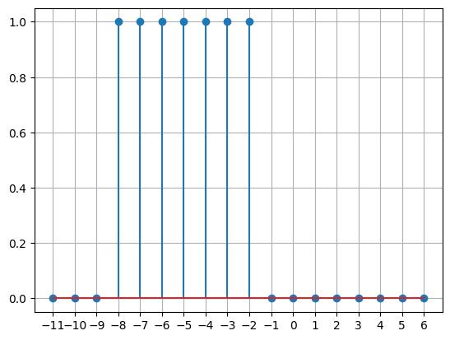
Output- After Reversing
# Amplitude Scaling:
A=3
signal=A*signal
plt.stem(modulated,signal)
plt.xticks(modulated)
plt.grid(True)
plt.show()

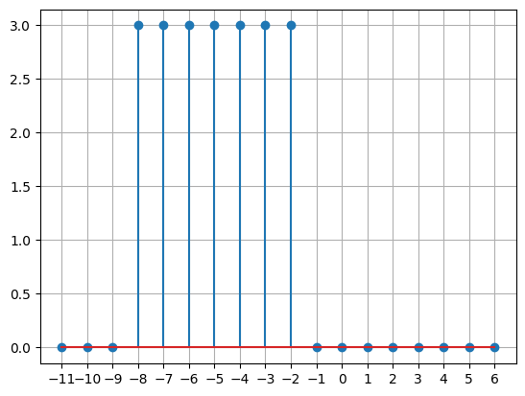
Output- After Amplitude Scaling

# Time Scaling:
T=2
def new_signal(x,y):
for i in range(len(x)):
if round(x[i])!=x[i]:
y[i]=0
return y
modulated=modulated/T
signal=new_signal(modulated,signal)
plt.figure(figsize=(10,5))
plt.stem(modulated,signal)
plt.xticks(modulated)
plt.grid(True)
plt.show()

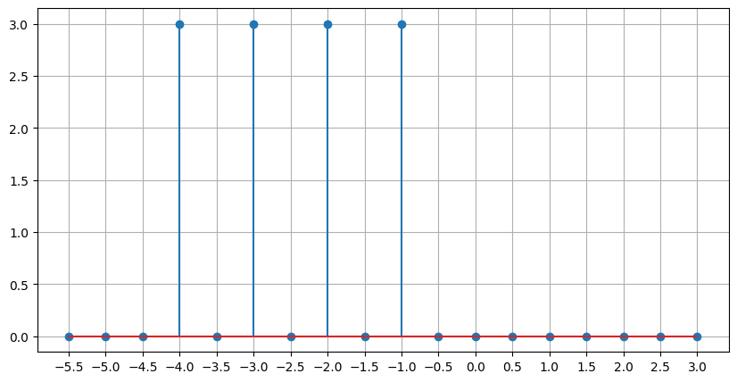
Output- After Time Scaling

Discussion:
- As the order matters, I have completed shifting as 1st operation then remaining others.
- For signal manipulation shifting the 1st priority.

